Gambar rajah berikut menunjukkan sebahagian gambar rajah entiti hubungan bagi sistem pangkalan data “The Summit Sporting Goods”.
The following diagram shows the partial entity relationship diagram for the “The Summit Sporting Goods” database system.O

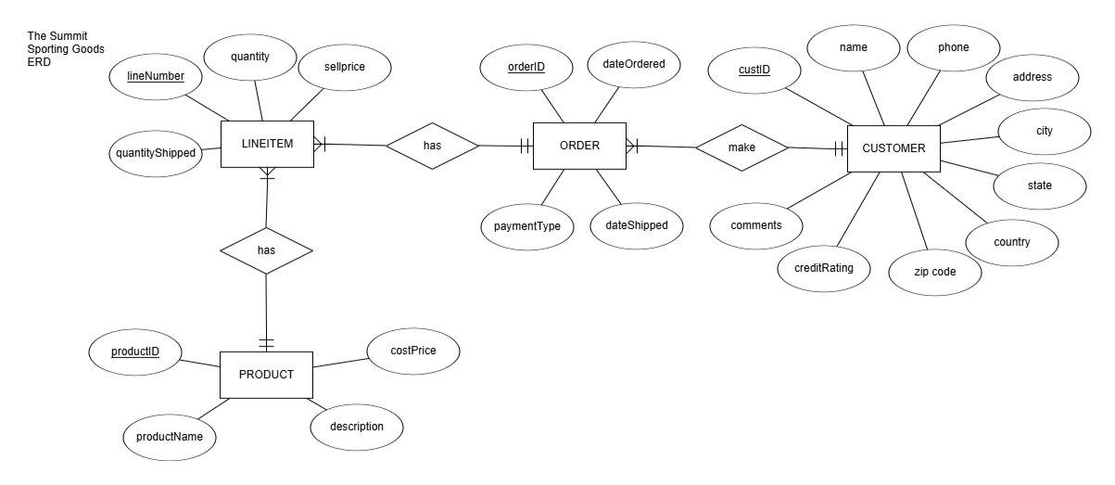

Anda diberi fail ‘Test2-K1.sql’ yang mengandungi arahan SQL untuk membina dan memasukkan nilai ke dalam jadual CUSTOMER, ORDERS dan PRODUCT seperti berikut:
You are given a file ‘Test2-K1.sql’ that contains the SQL commands to create and insert values into the CUSTOMER, ORDERS and PRODUCT tables as shown below:

CUSTOMER(custID, name, phone, address, city, state, country, zipcode, creditRating, comments)

ORDERS(orderID, custID, dateOrdered, dateShipped, paymentType)

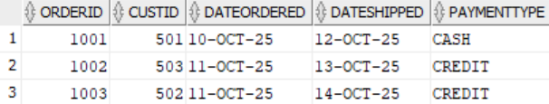

PRODUCT(productID, productName, description, costPrice,sellPrice)

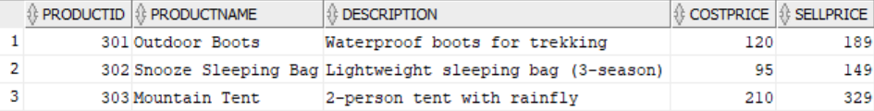

Nota/Note:
Semua soalan mesti dijawab mengikut turutan nombor soalan.
All questions must be answered according to the sequence of the question number.

Jawab soalan-soalan berikut menggunakan arahan SQL yang bersesuaian. Laksanakan arahan di dalam SQL Developer dan salin arahan dan output ke dalam kertas jawapan.

Answer the following questions using appropriate SQL statement. Execute the commands using SQL Developer and copy the command and output into the question paper.

- Bina jadual LINEITEM, serta masukkan data seperti berikut:
Create table LINEITEM and insert data as follows:

LINEITEM(lineNumber, orderID, productID, quantity, unitSellPrice, quantityShipped)

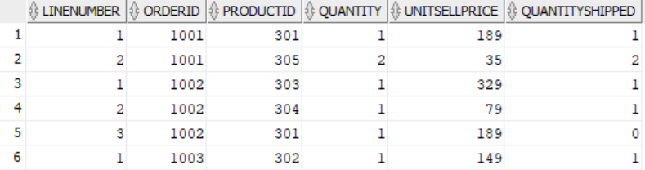

# orderID dan productID juga merupakan kunci asing.
# orderID and productID are also foreign keys.

Pernyataan SQL/SQL statement: [5M]
CREATE TABLE LINEITEM (
lineNumber INTEGER,
orderID INTEGER,
productID INTEGER,
quantity INTEGER,
unitSellPrice REAL,
quantityShipped INTEGER,
PRIMARY KEY (lineNumber, orderID),
FOREIGN KEY (orderID) REFERENCES ORDERS(orderID),
FOREIGN KEY (productID) REFERENCES PRODUCT(productID)
);

-- 2.inser data
INSERT INTO LINEITEM VALUES (1, 1001, 301, 1, 189, 1);
INSERT INTO LINEITEM VALUES (2, 1001, 305, 2, 35, 2);
INSERT INTO LINEITEM VALUES (1, 1002, 303, 1, 329, 1);
INSERT INTO LINEITEM VALUES (2, 1002, 304, 1, 79, 1);
INSERT INTO LINEITEM VALUES (3, 1002, 301, 1, 189, 0);
INSERT INTO LINEITEM VALUES (1, 1003, 302, 1, 149, 1);
COMMIT;

- Paparkan id, nama dan harga produk yang namanya mempunyai corak ‘oo’ mengikut turutan menurun id produk.
Display the product id, name and price where the product name has the pattern ‘oo’ in descending order of the product’s id.

Pernyataan SQL/SQL statement: [4M]

SELECT productID, productName, sellPrice
FROM PRODUCT WHERE productName LIKE '%oo%'
ORDER BY productID DESC;

Hasil Pertanyaan/Query Result: [1M]
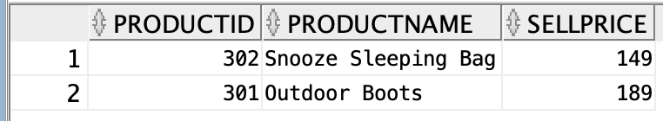

- Paparkan bilangan pelanggan bagi setiap kategori penarafan kredit. Paparkan hanya kategori penarafan kredit yang mempunyai sekurang-kurangnya dua (2) pelanggan.
Display the number of customers for each credit rating category. Show only credit rating categories that have at least two (2) customers.

Pernyataan SQL/SQL statement: [5M]
SELECT creditRating, COUNT(*) as num_customers
FROM CUSTOMER
GROUP BY creditRating
HAVING COUNT(*) >= 2;

Hasil Pertanyaan/Query Result:
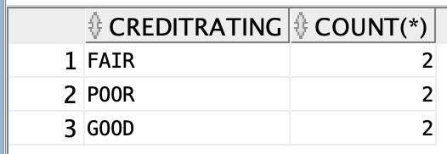

- Produk manakah yang harga kosnya lebih daripada harga kos purata?
Which product has the cost price greater than the average cost price?

Pernyataan SQL/SQL statement: [5M]
SELECT
productID,
productName,
costPrice,
(SELECT AVG(costPrice) FROM PRODUCT) AS averageCost
FROM PRODUCT
WHERE costPrice > (SELECT AVG(costPrice) FROM PRODUCT);

Hasil Pertanyaan/Query Result:
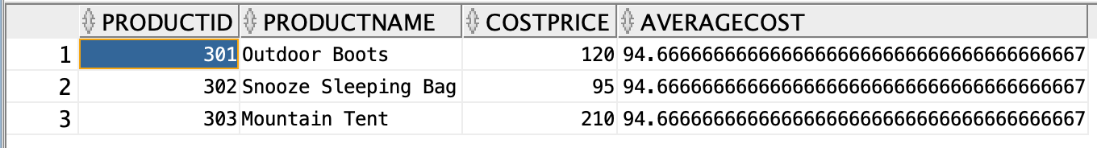

- Produk manakah yang mempunyai lebih daripada 1 pesanan?
Which product have more than 1 order?

Pernyataan SQL/SQL statement: [5M]
SELECT productID, COUNT(DISTINCT orderID) as num_orders
FROM LINEITEM
GROUP BY productID HAVING COUNT(DISTINCT orderID) > 1;

Hasil Pertanyaan/Query Result:
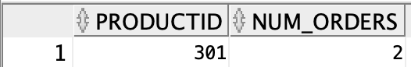

- Dengan menggunakan kenyataan NATURAL JOIN untuk mengabungkan jadual LINEITEM dan PRODUCT. Senaraikan id pesanan, id produk, harga kos, harga jual, untung (harga jual – harga kos), kuantiti dihantar, jumlah jualan (harga jualan * kuantiti yang dihantar) mengikut turutan id pesanan.
Using the NATURAL JOIN to join the LINEITEM and PRODUCT tables. List the order id, product id, cost price, sell price, profit (sell price – cost price), quantity shipped, total sale (sell price * quantity shipped) order by the order id.

Pernyataan SQL/SQL statement: [5M]
SELECT orderID, productID, costPrice, sellPrice,
(sellPrice - costPrice) as profit,
quantityShipped,
(sellPrice * quantityShipped) as totalSale
FROM LINEITEM
NATURAL JOIN PRODUCT
ORDER BY orderID;

Hasil Pertanyaan/Query Result:
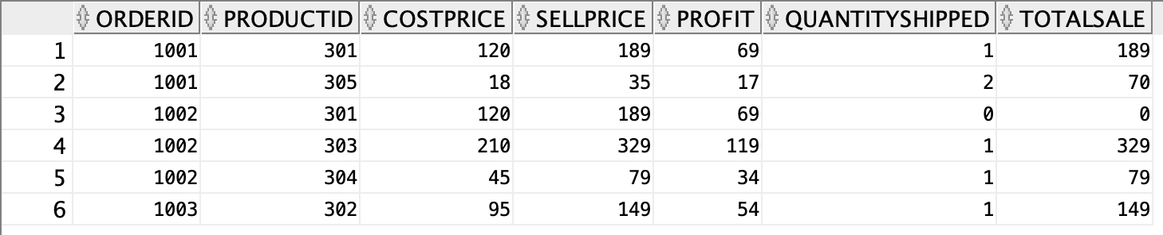

- Dalam jadual LINEITEM, hapuskan nombor baris 3 bagi id pesanan 1003. Kemudian kira bilangan baris dalam jadual LINEITEM.
In the LINEITEM table, delete line number 3 for order id 1003. Then count the number of rows in table LINEITEM.

Pernyataan SQL/SQL statement: [5M]
DELETE FROM LINEITEM
WHERE lineNumber = 3 AND orderID = 1003;
SELECT COUNT(*) as total_rows FROM LINEITEM;

Hasil Pertanyaan/Query Result:
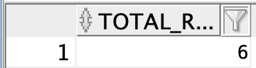

- Berapa ramai pelanggan yang membuat pesanan produk bernama ‘Mountain Tent’?
How many customers ordered the product named ‘Mountain Tent’?

Pernyataan SQL/SQL statement: [5M]
SELECT COUNT(DISTINCT custID) as num_customers
FROM ORDERS
JOIN LINEITEM ON ORDERS.orderID = LINEITEM.orderID
JOIN PRODUCT ON LINEITEM.productID = PRODUCT.productID
WHERE PRODUCT.productName = 'Mountain Tent';

Hasil Pertanyaan/Query Result:
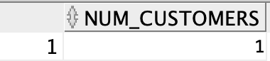
- Dengan menggunakan sub-pertanyaan, paparkan nama pelanggan yang membuat pesanan secara kredit (paymentType=’CREDIT’).
Using subquery, display the customer’s name who has ordered using credit (paymentType=’CREDIT’).

Pernyataan SQL/SQL statement: [5M]
SELECT name
FROM CUSTOMER
WHERE custID IN (
SELECT custID
FROM ORDERS
WHERE paymentType = 'CREDIT'
);

Hasil Pertanyaan/Query Result:
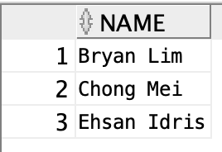

- Kemaskini harga jualan produk kepada tambahan 2% daripada harga jualan semasa. Senaraikan harga jualan terkini bagi semua produk.
Update the product’s sell price to an additional 2% increase from the current selling price. List the current selling price for all the products.

Pernyataan SQL/SQL statement: [5M]
UPDATE PRODUCT
SET sellPrice = sellPrice * 1.02;

SELECT productID,productName, sellPrice
FROM PRODUCT;

Hasil Pertanyaan/Query Result:
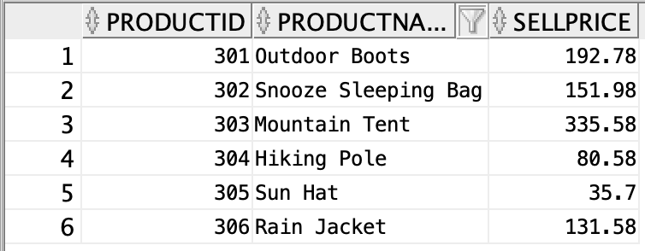

Tamat/The End

